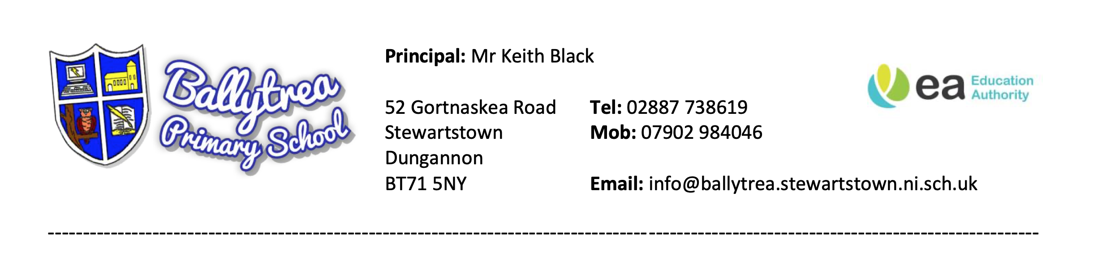
Friday 11th December 2020

Dear Parent,

You will be aware that Ballytrea PS has been hugely affected by Covid-19. Since September we have had 4 positive cases amongst our school community, resulting in class closures and general disruption to learning. We have followed PHA guidance in all these cases and we thank you for your patience and understanding when you were receiving texts, phone calls and emails that gave bad news.
As we enter the final week of this term, we are very aware that anyone who is required to self-isolate from 11th December onwards will be unable to join with their family on Christmas Day. This applies to both those who have tested positive and all close contacts such as those in the same class or travelling on the same bus.

We will be taking extra measures to ensure pupils and staff in each class are protected by further minimising movement of pupils and staff in school.

While school will remain open next week, if you feel it is safer for your child to remain at home, could you please let me know via email (info@ballytrea.stewartstown.ni.sch.uk) so that we can further support home learning. Your child will be marked present.
On Thursday 17th December a Christmas video will be posted on our school website. Please enjoy this celebration as we make the very best of Christmas 2020!
I would like to take this opportunity to thank each of you for your continued vigilance and support to keep our school community safe. It is greatly appreciated.

Yours sincerely,

Keith Black
(Principal)

