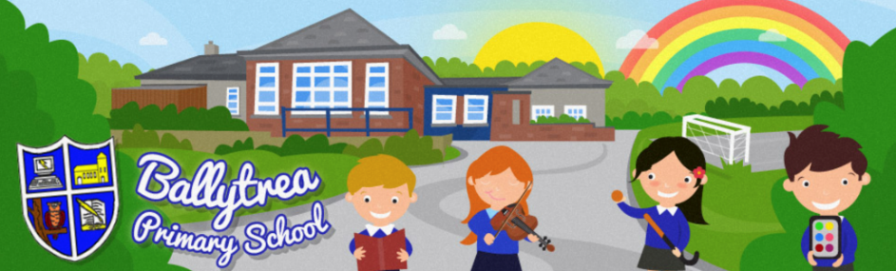
www.ballytreaps.com
52 Gortnaskea Road,
Stewartstown,
BtT71 5NY
Tel: 028 877 38619
Contingency Plan
(Up and until school closes)
Dear Parent(s),

At school we continue to put into place different measures to ensure the safety and wellbeing of our pupils, staff and families. As such, I ask that you read the following contingency plan carefully and adhere to any instructions within.

Thank you once again for your continued support and understanding.

Yours sincerely,

Mr Black
Principal

Cleaning | - Enhanced cleaning routines have been instigated to ensure that surfaces and ‘touch points’ such as door handles, light switches, keyboards and telephones are regularly disinfected.
Personal Awareness and Hygiene | - In compliance with PHA guidance, pupils and staff will continue to practice good personal hygiene. This will include regular hand washing throughout the school day.  - Hand washing will be mandatory on arrival at school, before eating, after breaks and after using the bathroom.  - Additional hand washing facilities will be operated in each classroom. Classrooms are also stocked with soap, paper towels and tissues.  - ‘Catch it, Bin it, Kill it’ will be encouraged with the pupils if they need to cough or sneeze.  - School will encourage the pupils not to touch their eyes, nose and mouth with unwashed hands.  - Teachers and staff will continue to use recommended resources to teach pupils about the importance of good personal hygiene.
Symptoms of  COVID-19 | - Pupils/Staff displaying any symptoms relating to the COVID-19/Coronavirus should not come to school. This also applies to any sibling who has been in contact with the symptomatic pupil.  - Any pupil or staff member who displays any symptoms of the virus whilst at school, will be sent home and asked to self-isolate for 14 days. (At this point there is no need to close the setting or to send other pupils/staff home)  - In the event that a pupil or staff member is confirmed as having the COVID-19/Coronavirus, we will be contacted by the Local Health Agency to discuss the case, identify people who have been in contact with them and advise on any actions or precautions that should take place.  - Advice on the cleaning of communal areas such as classrooms, changing rooms and toilets will be given by the PHA.  - If there is a confirmed case of the COVID-19/Coronavirus, a risk assessment will be undertaken by the school with advice from the PHA. A decision will then be made in relation to the potential closure of the school.
Parents/Families | - Parents are asked not to enter the school building when dropping their children off in the morning or collecting their children at the end of the school day. Staff members will be there to meet and release all pupils.  - If communication is required with the school or your child’s teacher, we ask that you ring the school (028 877 38619) or communicate via email.  (info@ballytrea.stewartstown.ni.sch.uk)  * We appreciate that this goes against the schools ‘open door’ policy, however by limiting the traffic in and out of school it will help us to ensure the safety and well-begin of all.
Other Visitors to School | - Visitors to the school should wash their hand when entering the school building and will be asked to follow other school protocols in relation to this matter.  - The school will continually monitor the situation with regards to the necessity of visitors being allowed into the school building.
Other Considerations / Alterations | - Morning / Fun Club will continue to be operated as normal. Above plans will apply.  - A school mobile telephone is now in place in order to contact the school principal out of hours or in the event of school closure. This phone number will be passed on to parents via a letter sent home with the pupils.  - Parents will be kept up to date with developments through the school’s website, Facebook page and if needed by letter or text message.  - Parents are encouraged to download the ‘SCHOOLS NI’ app in order to receive school information messages.  - Teaching staff have begun to prepare ‘Activity Packs’ for the pupils in the event of school closures. (Following advice from EA and the teaching unions)  - School will remain open until such time as the Government or the Department of Education decide otherwise.  - At all times the school will follow the advice given to us the PHA.

* A contingency plan has also been put into place with regards to a school closure. This will be communicated with the school community in due course.

