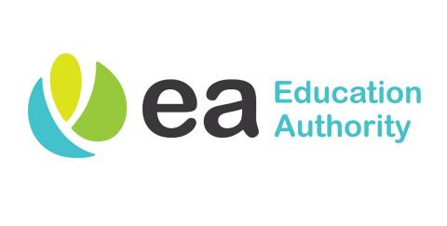
Principal: Mr Keith Black

52 Gortnaskea Road Tel: 02887 738619
Stewartstown Mob: 07902 984046
Dungannon
BT71 5NY Email: info@ballytrea.stewartstown.ni.sch.uk

----------------------------------------------------------------------------------------------------------------------------------------------

Wednesday 30th September 2020

PARENT UPDATE

Dear parent(s),

It is hard to believe that we have now reached the end of September. It has been fantastic to see the children back in the classroom, learning together and enjoying daily interaction with their friends and peers.

I would like to thank all our parents and the wider school community as a whole, for their support and encouragement throughout our period of school reopening. It has been very much appreciated by the staff at our school. I ask that in the coming weeks and months you continue to support our pupils and staff, as it is through partnership and positive relationships that we will be continue to successfully navigate through these uncertain times.

I would also like to publically thank all the staff at our school for their hard work and dedication since our restart in August. We are so fortunate to have a team of staff at Ballytrea who regularly go above and beyond for our pupils and who have ensured the safe return to school for all.

Over the coming weeks we are sure to face more challenges, and I ask that our school community continues to follow the advice given by the authorities. If your child is displaying any of the following symptoms, they should not come to school:

* new continuous cough and/or
* high temperature and/or
* a loss of, or change in, normal sense of taste or smell (anosmia)

If you have any queries or questions in the coming days, please do not hesitate to contact the school.

Yours sincerely,

Keith Black
(Principal)

* Please see overleaf for further key information for parents.

Primary One

As of Monday 5th October 2020, Primary One pupils will stay in school until 2pm. Pupils will be able to avail of a school dinner (priced at £2.60 per day) or may bring their own packed lunch.

School Bags

As of Monday 5th October 2020, all pupils in school are permitted to bring a school bag to school. This is solely to help with the organisation of home learning resources and there is no need for pupils to bring their own pencil cases or stationery to school; stationery will still be provided for each child in class. Pupils are also reminded not to bring any unessential items or toys to school.

Healthy Eating

This week, in conjunction with ‘Healthy Eating Week’, the children have been completing some activities in class, highlighting the message of Healthy Eating and a Healthy Lifestyle. Whilst we will not see any child go hungry in school, it is important that those children who are bringing snack or a packed lunch to school bring healthy items to eat. Items such as chocolate bars, sweets and sugary drinks are very much discouraged.

I would also like to remind you that healthy snack is available to be purchased from our school canteen, with items priced at 30p each.

Pupil Homework

Homework activities for all pupils will commence on Monday 5th October 2020. As mentioned previously, homework will be communicated to pupils and parents via the Microsoft Teams App. Details of how to access your child’s account are available on our school website.

Your child has been sent home from school today with a laminated card which has all of their username and email details written on it. If you are having any difficulty accessing the programme, please get in touch.

We are expecting some teething problems as we begin to use this online platform, so please work with us as we all get used to this new addition to our homework routine.

