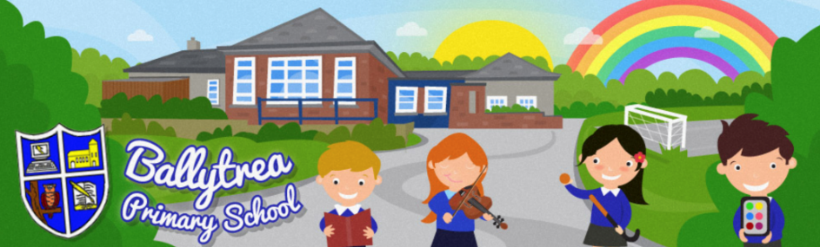
www.ballytreaps.com

52 Gortnaskea Road,
Stewartstown,
BT 71 5NY

Tel: 028 877 38619

Wednesday 13th May 2020

Home Learning - Update

Dear Parent(s),

It is really hard to believe that we are now in week 8 of our school closure. The remote learning that you have been carrying out with your children has been invaluable and I would once again like to thank you for all your help and support. You really are doing a wonderful job!

At school we are fully aware that all children develop and learn at their own pace and level. We take this into consideration with all teaching and planning and continue to do so as we prepare further home learning materials for our pupils. We also appreciate that each family’s home situation is very different and as such we do not want to bombard or overload anyone with additional materials that they are not ready for.

Therefore, rather that supplying everyone with new materials next week, we will only be providing additional materials for those who are ready for them. If you child is ready to move on and has completed the majority of tasks previously set, could you please text or email Mr Black by Friday 15th May at 5pm.

Mobile Number: 07902 984046
Email: kblack585@c2kni.net

* Arrangements for the collection of new materials will be shared with you on receipt of this request.

At the moment there is a lot of uncertainty about school arrangements moving forward into next year, however, please be reassured that when I have any further information for you, it will be shared as soon as possible.

I will be in contact with you over the next number of weeks to inform you of your child’s class grouping and teacher(s) for next year, however I will not be releasing the holiday list for 2020/21 just yet. I intend to wait until I have a clearer picture of what school life will be like for us before I do.

If you have any questions and queries regarding this or any other matter, please do not hesitate to get in touch.

Kind Regards,

Mr Black Tel: 028 877 38619
(Principal) Email: kblack585@c2kni.net

