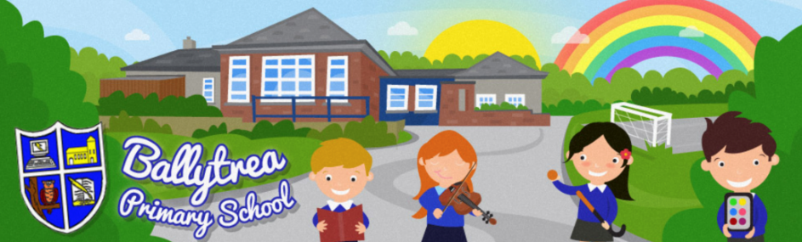
www.ballytreaps.com

52 Gortnaskea Road,
Stewartstown,
BtT71 5NY

Tel: 028 877 38619

Thursday 23rd April 2020

Dear Parent(s),

I hope that you and your loved ones were able to have a somewhat enjoyable break over the Easter period and have settled back into home learning with your children. I once again want to thank you for your continued support and for the efforts that you have been putting in with your children at home. I appreciate that it is not an easy task and that it will not replace the learning your children should be doing at school, however I want to reassure you that you are doing a wonderful job and the positive effect that your efforts are having on your children will not be lost.

The main purpose of this letter is to inform you of the next stage of home-learning for you children. As mentioned in previous correspondence the initial packs of work sent home were to cover your children until Monday 27th April. (Some tasks sent home by Mrs Colvin/Mrs Patterson should cover a longer period of time).

The teachers have been busy preparing further learning for your children and these packs will be available to be collected from school on Monday 27th and Tuesday 28th April from 10am-2pm. The packs will be left in labelled ‘class’ boxes at the front of school, where you can pick up your child’s work, free from contact with anyone else. Each pack is labelled with your child’s name.

* Some individual class information on the packs.
Mrs Bleakley | * Completed reading books can be left in the labelled box at the front of school.
Mrs Colvin /  Mrs Patterson | * Completed reading books can be left in the labelled box at the front of school.  * Quite a lot of work in home learning packs. This should last up until the end of May / beginning of June at least. Please go at your child’s own pace and don’t get overwhelmed and feel that it all must be completed.
Mr Black /  Mrs Craig | * Completed reading books can be left in the labelled box at the front of school.  * No new reading books have been sent home. The children should choose their own reading material from home and read at least 4x20 minutes per week.  * The children’s mental maths and assessment workbooks have been sent home. The children can work through some of these tasks to break up their other learning.

* At the moment it is anticipated that the next round of home learning packs will be released on Monday 18th May.

Please do not be alarmed if you do not have all the tasks completed that were initially sent home. At school we appreciate that everyone’s home circumstances are different, and you can only do so much. We know that it is not easy juggling home-learning, parenting and possibly your own work as well!

With regards to tasks that the children have already completed; some of these can be returned to school when picking up your child’s new packs. Please leave any work (labelled with your child’s name) in the appropriate box.

I must advise you however, that not all of this work will be marked, assessed or returned to you. As I am sure you are aware the children have completed a substantial amount of work at home, therefore the teachers will only be tasked with assessing completed work which they deem necessary and will more importantly be observing the learning that your children have been doing. This will be carried out as a means of informing future planning and teaching, and not as a means of giving informative feedback to the children.

Finally, I would like to also convey my admiration and thanks to all those members of our wider school community who continue to work on the frontline with the NHS, or who are key workers that day and daily put themselves at risk to keep the country going. At Ballytrea PS we really appreciate the efforts you are making and are extremely thankful to you all.

If you have any further queries, please do not hesitate to get in touch.

Kind Regards,

Mr Black Tel: 028 877 38619
(Principal) Email: kblack585@c2kni.net

