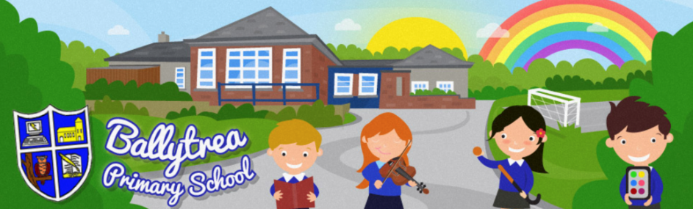
www.ballytreaps.com
52 Gortnaskea Road,
Stewartstown,
BtT71 5NY
Tel: 028 877 38619
Parent Update
3rd April 2020

Dear Parent(s),

As we come to the end of our second week of school closure, I write to you today in the hope that you and your families are well and continuing to take every precaution instructed by our government. I’m sure it is a very strange and unsettling time at home, however we live in the hope that things will get back to some sort of normality as soon as possible.

I want to commend all those from within our school community who are working on the frontline or who are providing vital services to keep our families safe and the country going. Our thoughts are very much with you all!

In school we have been able to provide support for key worker families over the last two weeks, however school will now be closed as of Monday 6th April, for two weeks. At all times we must take the safety of the children and the staff into consideration and this has always been at the forefront of our thinking. This has been a very difficult decision to make, however we will continue to monitor the situation closely and any decisions on the future opening/closure of the school will be made in due course.

I would like to thank you all for the unreserved support and understanding you have shown the school over the last number of weeks as we have tried to navigate this situation as best as possible. I also want to thank you for the school work that you have been doing with your children at home. This is vitally important to your children and for some parents, who may also be trying to work from home, it is something that I know has not always been easy. We really appreciate your efforts.

As the next two weeks were due to be your child’s school holidays, no work has been set for the children to complete. We ask that you stick to this and give both your children and yourselves a little break. This has been a challenging time for us all and a break will do everyone the world of good. We will get back in contact with you, when the time comes, to inform you of future arrangements for home learning. You should however, still have work set for your children to complete for the week beginning Monday 20th April 2020.

For those parents who have been following Facebook and our school website for our daily challenges, I want to thank you for allowing and encouraging your children to take part. It been a great way for our school community to stay connected and I know the staff have enjoyed getting to see the children and what they have been getting up to. We will take a break over the next two weeks, however please don’t be fretting, I have plenty more challenge ideas up my sleeve!

Finally, I would also like to acknowledge the hard work that our school staff have been doing over the last number of weeks, both in caring for the children of key worker families and providing families with resources and activities for remote learning. I very much appreciate the enormous contribution that you have made.

Please remember that although school is now closed, you can still contact your child’s teacher with any home learning queries or myself with any other queries in relation to school.

Please email info@ballytrea.stewartstown.ni.sch.uk or call the school mobile on 07902984046.

Yours sincerely

Mr Black
Principal

* Future communications will continue to be made through our school website and Facebook page so please keep a regular eye on both.

