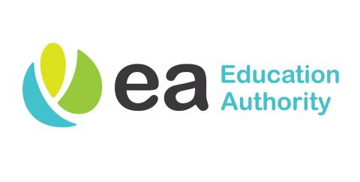
Principal: Mr Keith Black

52 Gortnaskea Road Tel: 02887 738619
Stewartstown Mob: 07902 984046
Dungannon
BT71 5NY Email: info@ballytrea.stewartstown.ni.sch.uk

----------------------------------------------------------------------------------------------------------------------------------------------

Sunday 20th February 2022

Covid 19 - Letter to Inform

Dear Parents,

Over the half-term break, several members of our school community have tested positive for Covid-19. No one else in school has been identified as a close contact by the PHA but, as a matter of courtesy, I am letting you know.

There is no need to be concerned.

However, as per the current guidelines, if your child has not had a positive test, we would encourage you to:

Do regular Lateral Flow Tests with your child
Keep a very close eye for symptoms developing

Additionally, if your child is unwell, please keep him/her at home.

At school we have been very fortunate up until now in that we have not experienced the levels of pupil and staff absence that other schools have recently. However, as we now have rising case numbers, it is very important that we remain vigilant and continue to take all appropriate steps to keep everyone safe.

We will do our best to keep any disruption at school to a minimum.

Many thanks for your understanding,

Mr K Black
(Principal)

